### Unit Test

|  |  |  |  |  |  |
| --- | --- | --- | --- | --- | --- |
| No. | Test Title | Pre-Condition | Test Steps | Expected Results | Actual Results |
| 01. | View about page | Accessible form home page and any other pages | Click on “About Liberty” drop down menu and select About Liberty option to view the about page. | The test result was as expected. | As expected. |

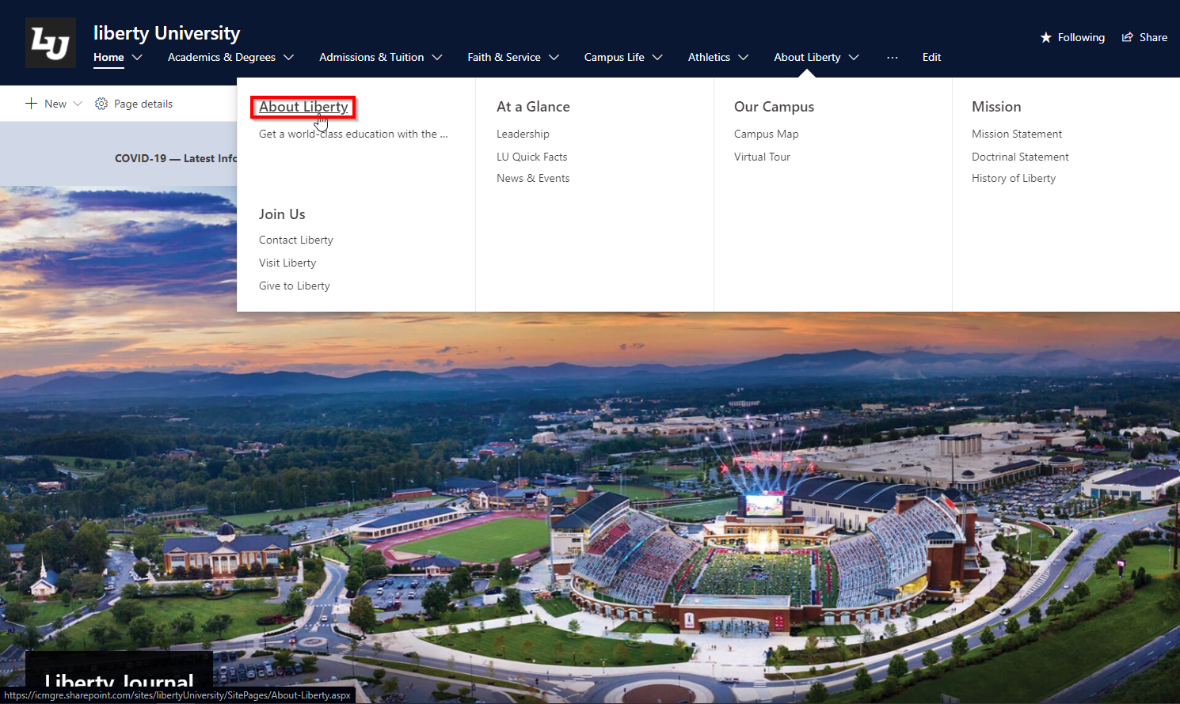

Figure 1 Click on about liberty and press About Liberty option.

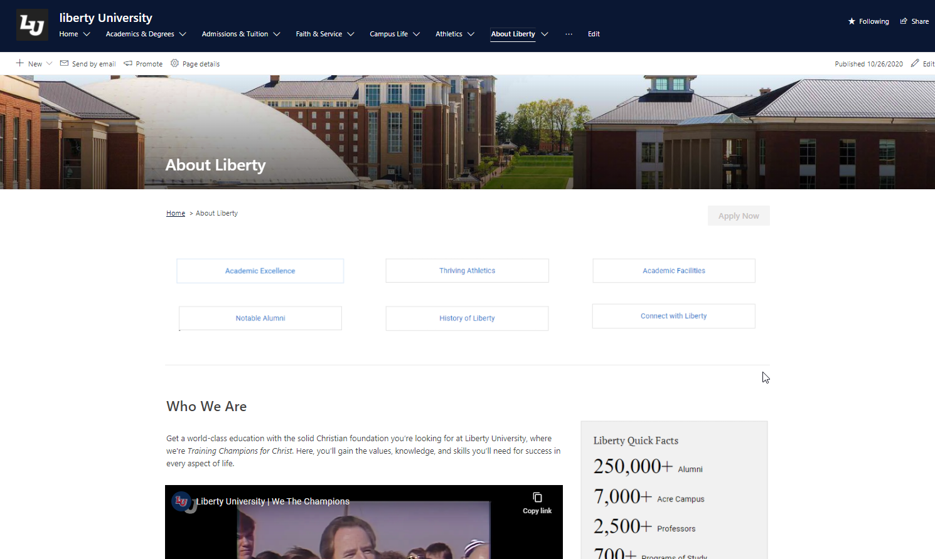

Figure 2 Viewing About page.

|  |  |  |  |  |  |
| --- | --- | --- | --- | --- | --- |
| No. | Test Title | Pre-Condition | Test Steps | Expected Results | Actual Results |
| 02. | View Contact Page | Accessible form home page and any other pages | Select the “About Liberty” drop down option from the navigation bar and select “Contact Liberty” option this will take the user to the Contact page of the university. | The test result was as expected. | As expected. |

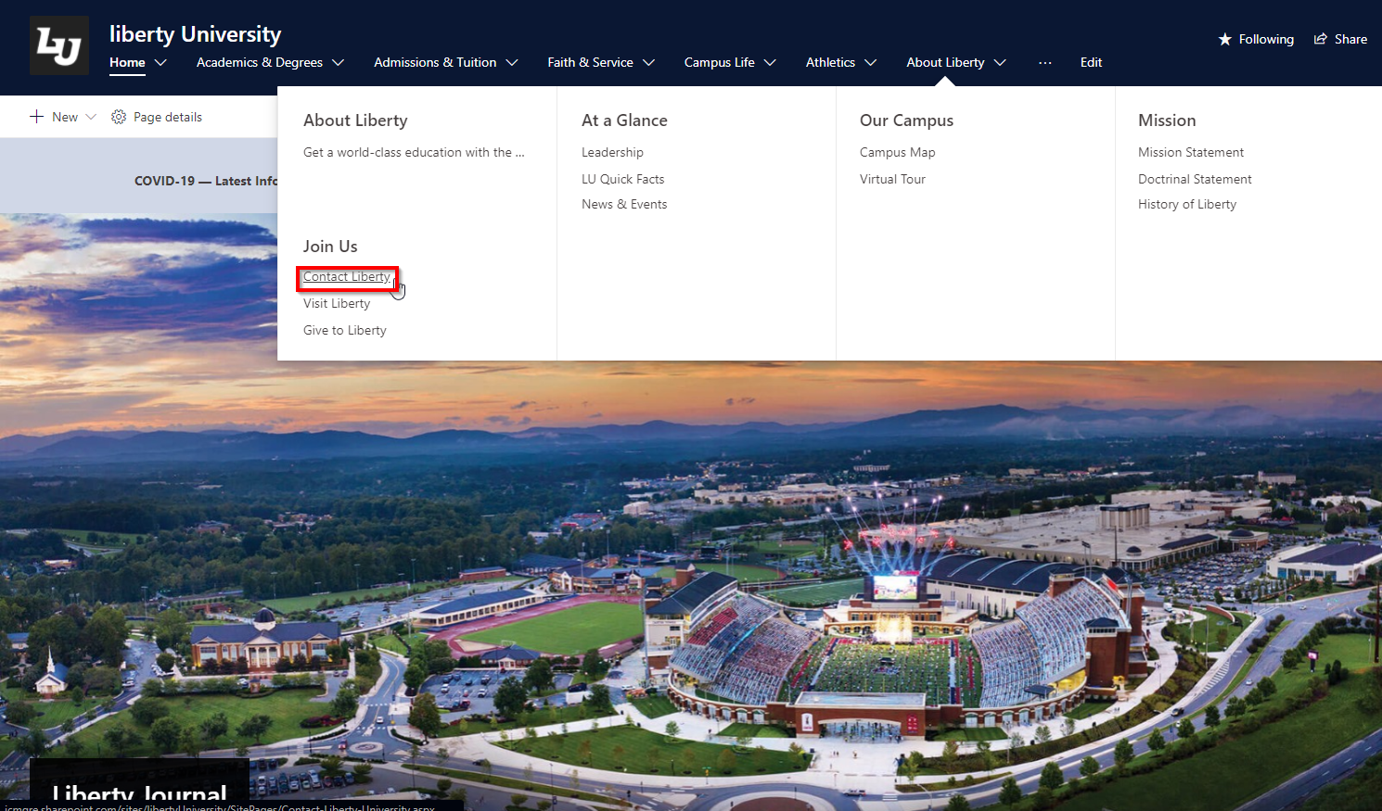

Figure 3 Click on about liberty and press Contact Liberty option.

